Ciena Insights

User Guide (v1.0)

October 23,2018

Table of Contents

1 Introduction 3

2 Log in 4

3 Home Dashboard 5

3.1 Network View 5

3.2 Notifications 5

3.3 Top Ports Utilized 6

3.4 Top Unavailable Devices 6

3.5 Top Unhealth Ports 6

3.6 Top Nodes 6

4 Dashboards 7

5 Assets 8

6 Availability 10

6.1 Sites 10

6.2 Availability Chart 10

6.3 Port List 10

6.4 Availability Over Time 11

7 Capacity 12

7.1 Network 12

7.2 Lists 13

8 Health 14

8.1 Sites 14

8.2 Risk Priorities 15

8.3 Risk Details 15

8.4 PM Graph 18

# ****Introduction****

The Ciena Insights is a portal that Ciena provide to customer to monitor their network health. There are 4 main Apps within the Portal. They are Assets, Availability, Capacity and Health. The Assets Dashboard provides an inventory list of network elements within the network. The Availability Dashboard provides a high level “at a glance” view of Network Availability Over Time for a 7 day running period and a current Port Availability Chart. The Capacity Dashboard provides a link utilization view between the sites in the network. The Health Dashboard is a more effective app for NOC Engineers to look at High/Medium/Low risk ports that are listed in alphabetical order within their respective risk groups. This is a good way to identify network risks and poor performance before they actually impact customer data services.

# ****Log in****

1. Open a web browser and type in following URL to connect to the Cloud Analytics Services Portal.

https://<hostname>/analysisportal/

1. Type in your user name and password to log in.



1. The Ciena Insights home dashboard is displayed.

# ****Home Dashboard****

The home dashboard consists of 6 parts:

* Network View
* Notifications
* Top Ports Utilized
* Top Unavailable Devices
* Top Unhealthy Ports
* Top Nodes

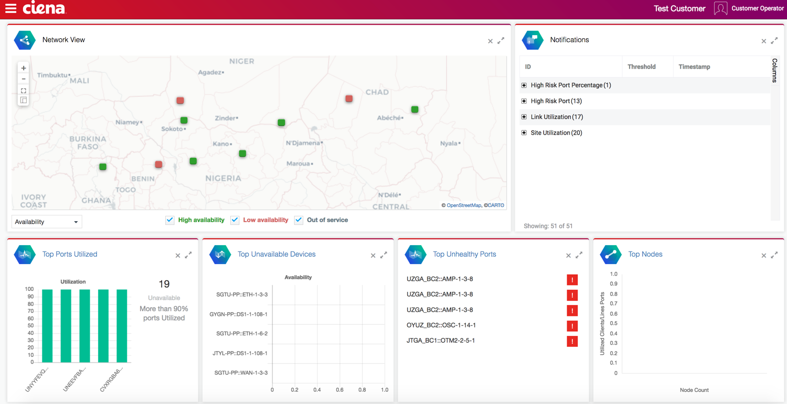

## Network View

This is interactive map can be changed based on user selection. The map can be zoomed in or out, and zoom to fit all sites. Use map index can quickly locate set of devices on the map.

User can check or uncheck the HA, LA or OOS check box to change the view of the network elements on the map.

## Notifications

## Top Ports Utilized

## Top Unavailable Devices

## Top Unhealth Ports

## Top Nodes

# ****Dashboards****

1. Click on the menu icon on the top left side, expand the “Dashboards” icon. A list of application dashboards is displayed:

* Asset
* Availability
* Capacity
* Health

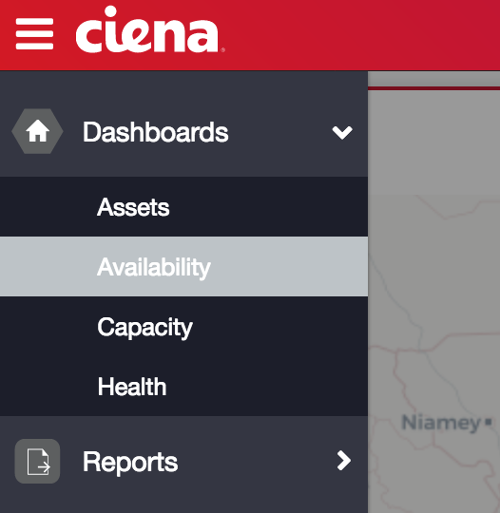ß

1. User also can switch the dashboard in the middle of the main screen depends on user’s configuration.

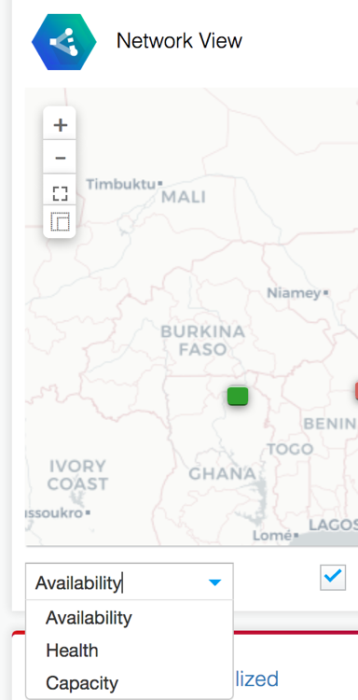

# ****Assets****

The Assets dashboard consists 4 parts:

* Site
* Asset Status
* PEC Code and Nodal Licensing
* Inventory List

It gives user a quick idea of the inventory of NEs existing in the customer network.

**Site:** It provides the device location on a geography map.

**Asset Status:** Percentage of devices in EOL (End Of Line), EOS (End Of Services), Up-to-date and Not up-to-date status.

**PEC Code & Nodal Licensing:** It provide device PEC code and license information.

**Inventory List:** It provides NE detailed hardware information grouped by TID.

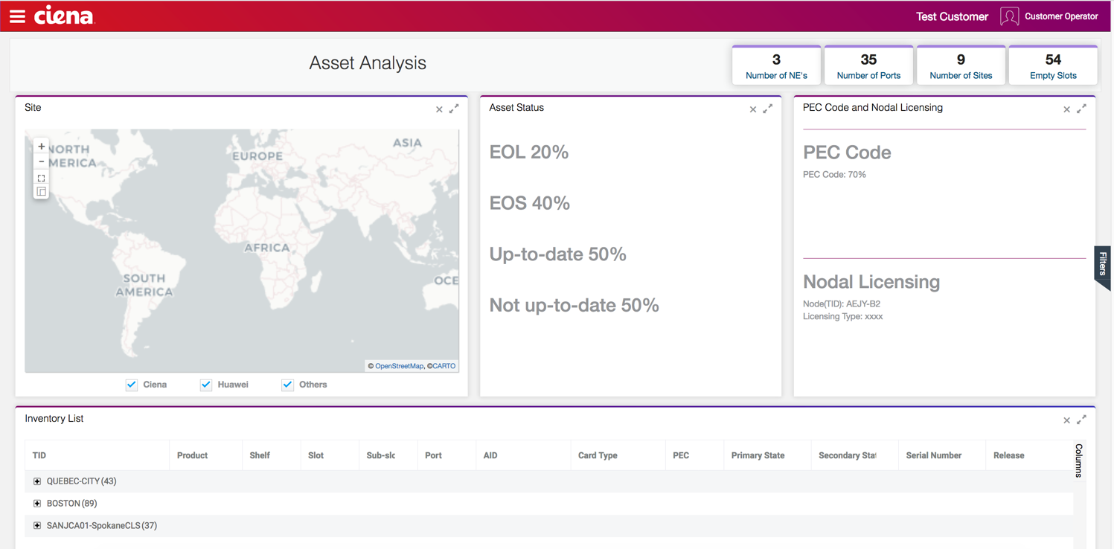

Inventory List view:

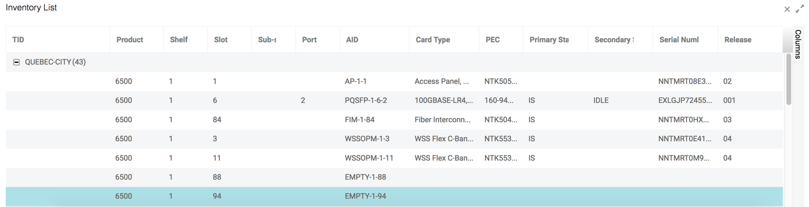

Click on the “Columns” tab and configured the filters to display the device hardware information as desired:

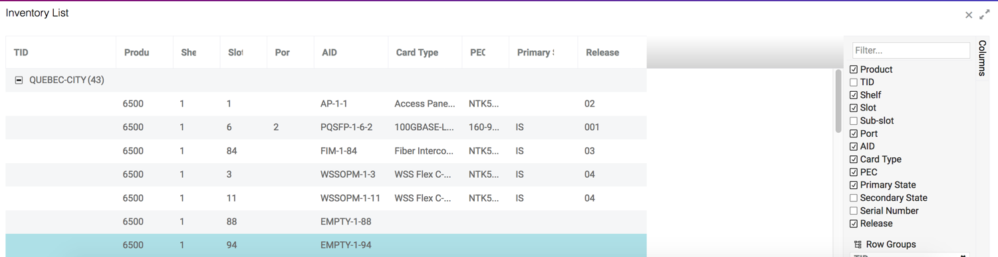

# ****Availability****

The Availability Analysis dashboard consists 4 parts:

* Sites
* Availability Chart
* Port List
* Availability Over Time

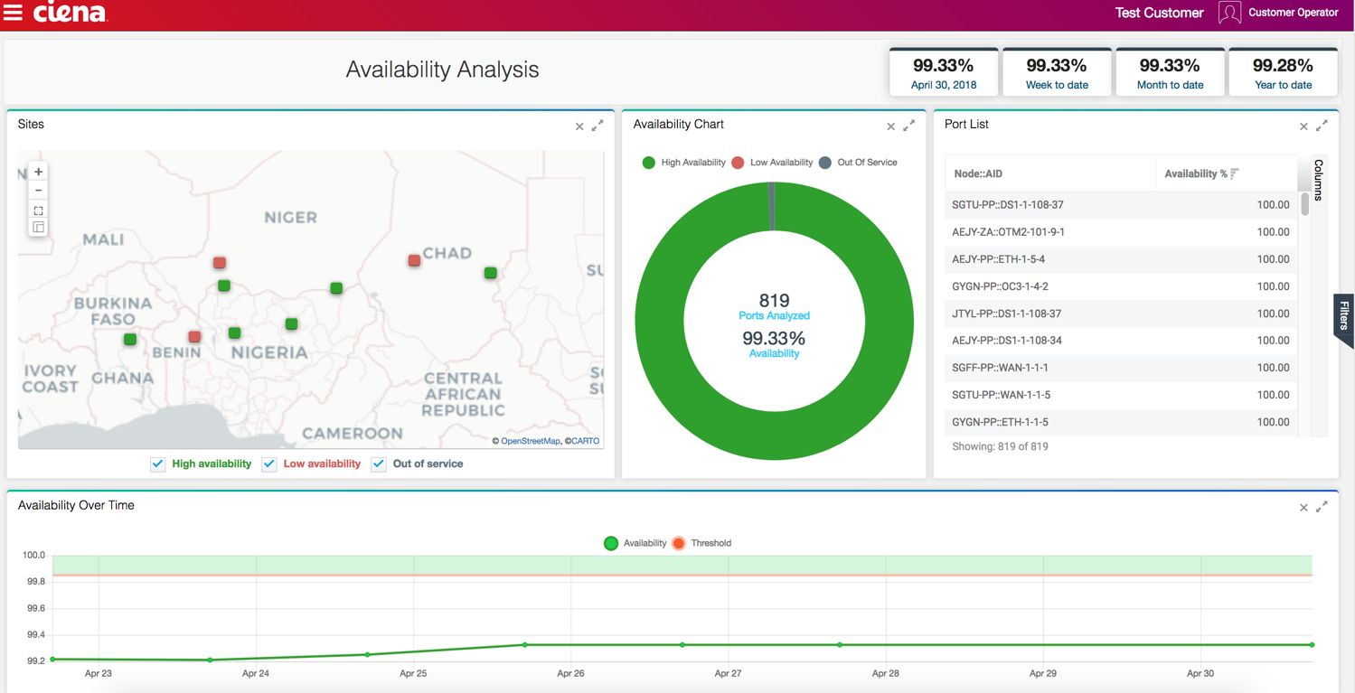

## Sites

This is interactive map can be changed based on user selection. The map can be zoomed in or out, and zoom to fit all sites. Use map index can quickly locate set of devices on the map.

## Availability Chart

The availability chart shows the HA (High Availability), LA (Low Availability) and OOS (Out Of Service) ports percentage in the network.

## Port List

The port list displays the availability of a port on a node. Use the “Columns” tab to display Node and AID or Availability only or both.

Use the “Filters” tab to configure the Date, Network, Node, hardware information and Availability Level to filter out the data that user is interested.

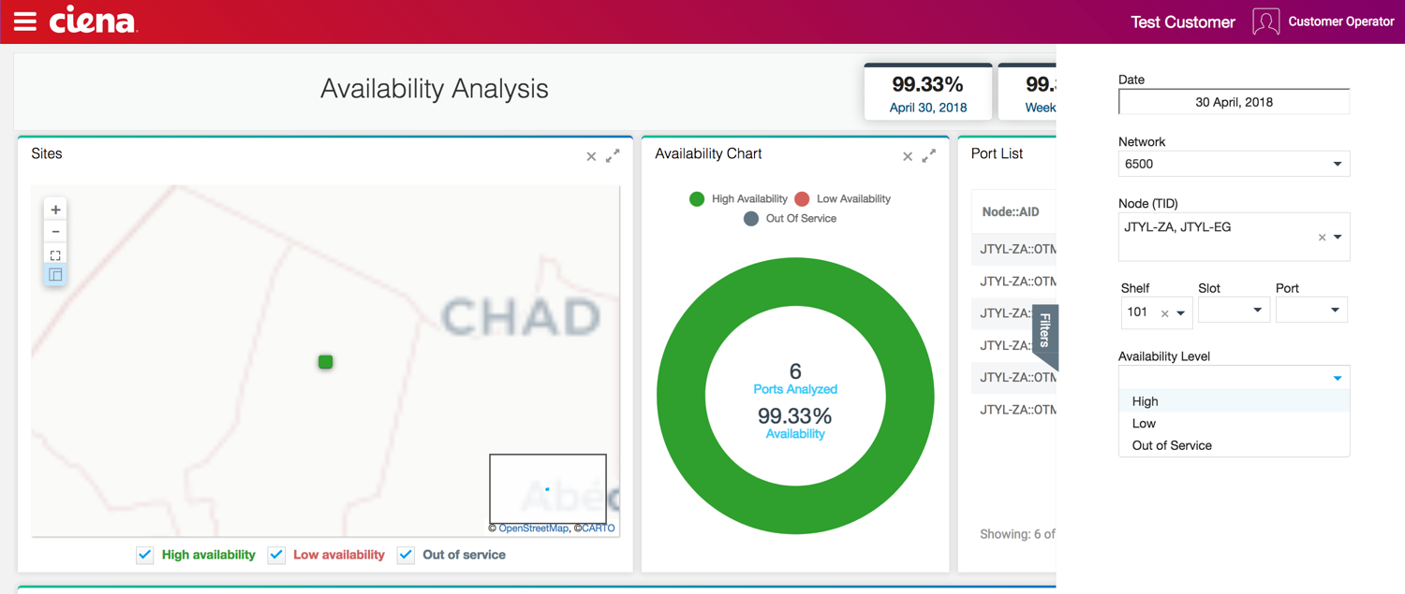

## Availability Over Time

This chart displays the availability over time for the last 7 days. Giving a visual “at a glance” of any drop in service. Any fiber outages or MI’s that involve fibers will show as a dip here.

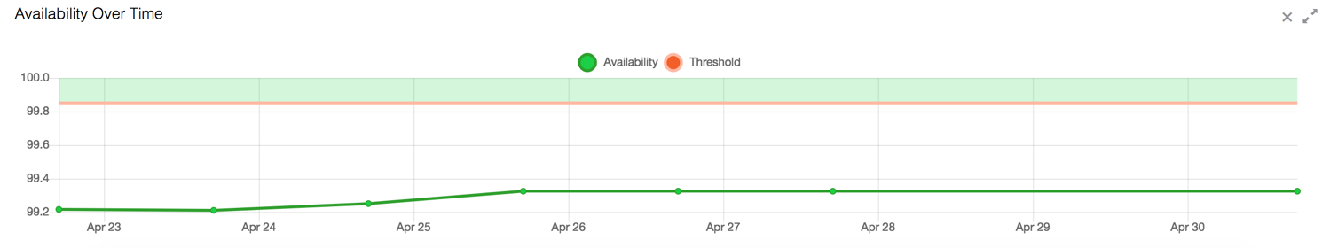

# ****Capacity****

The Smart Capacity Dashboard consists 2 parts:

* Network
* Lists

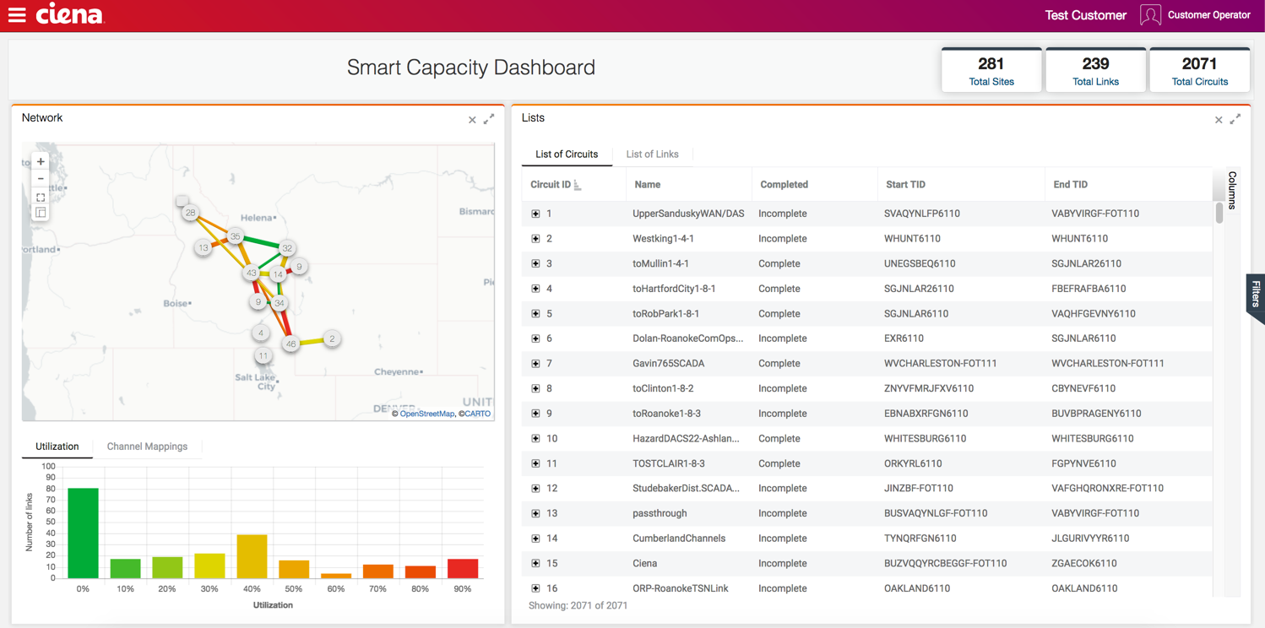

## Network

This is interactive map is changeable based on user selection. The map can be zoomed in or out, and zoom to fit all sites. Use map index can quickly locate set of devices on the map. The color of the line indicate the link utilization between the two sites.

Click on a node in the map will display the site detailed information.

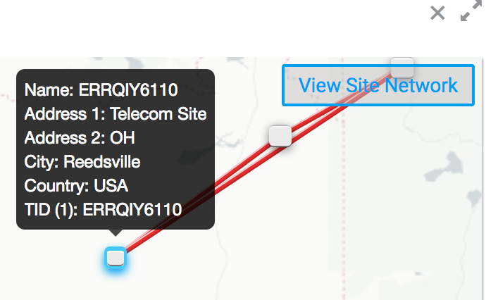

## Lists

Click on the links in the Network map, the Lists window will display the link information correspondingly including the Circuit ID, Name, status, Start TID and End TID.

Use the “Columns” tab to filter out the data only interested.

Use the “Filters” tab to pull out the filter menu to configure the Product Type, Node TID, Shelf/Slot/Port information to display the data as required.

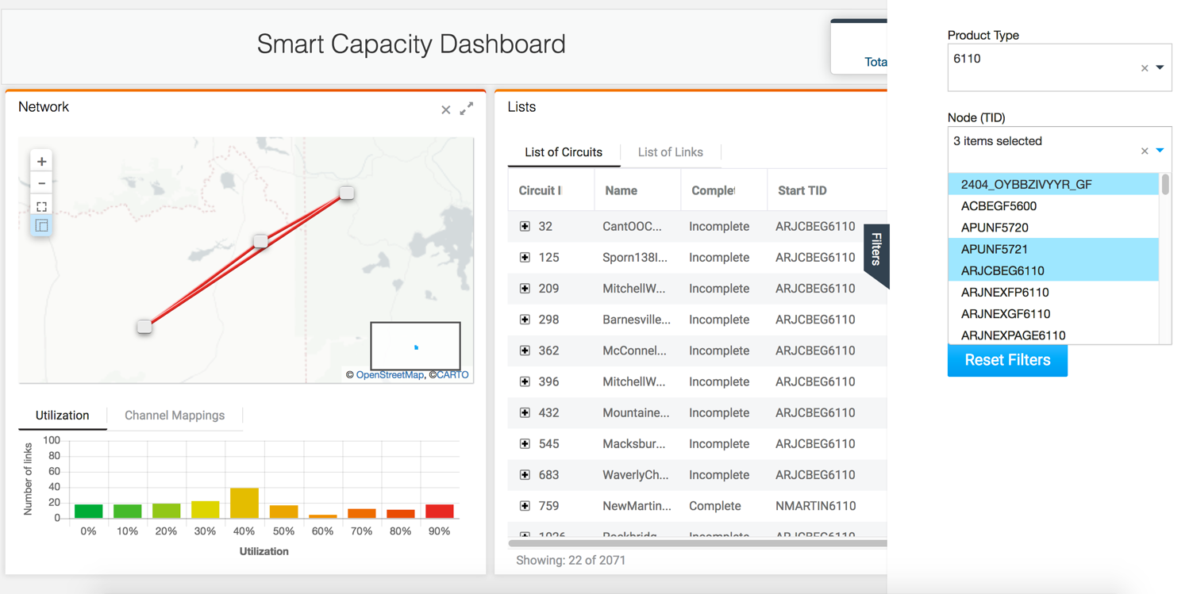

# ****Health****

The Network Health Dashboard consists 4 parts:

* Sites
* Risk Priorities
* Risk Details
* PM Graph

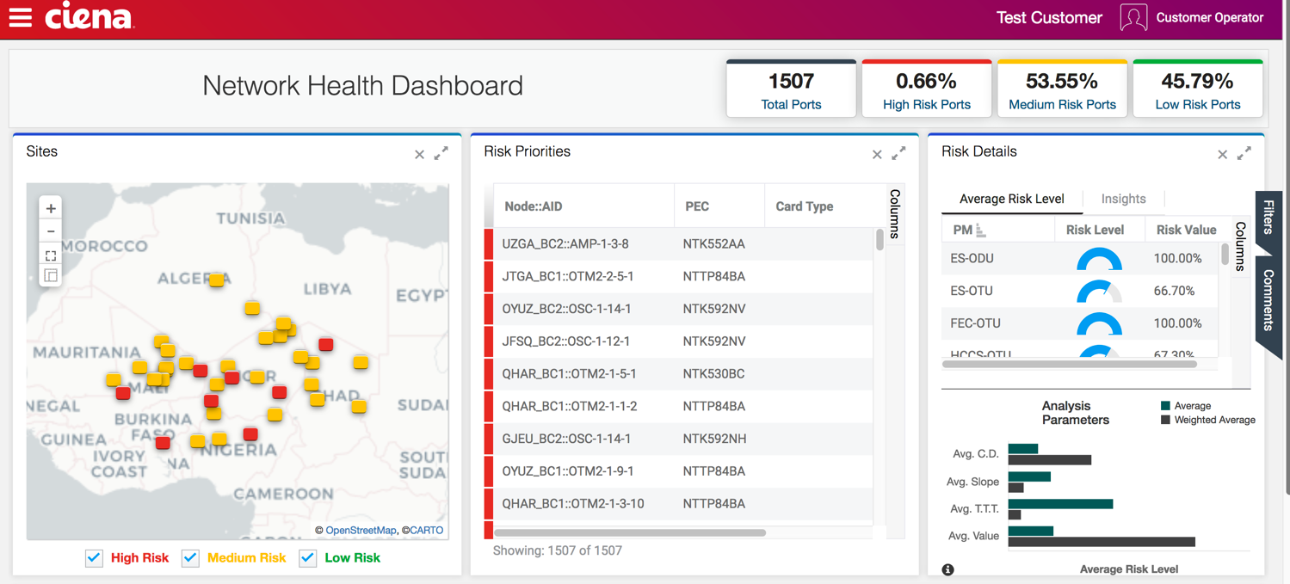

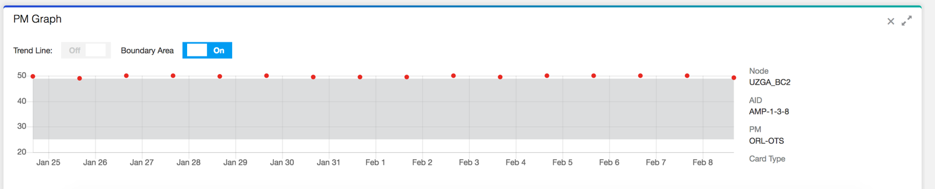

## Sites

This is the same interactive map that was seen in the previous dashboard and behaves in exactly the same way and is linked to which ever node is selected. Default is set to the top level map but this will change once a node is selected from the list. To go back to the top level map simply refresh the page.

## Risk Priorities

This is split into 3 categories, High, Medium and Low risk which are also color coded red, yello and green accordingly. The default here is for the highest risk node to also be displaying on the PM chart at the bottom of the page. User can easily navigate through the highlighted risks and see the chart instantly then be able to make an educated decision as to whether this needs further investigation at this time.

Use the “Columns” tab to select or un-select the fields to display the data.

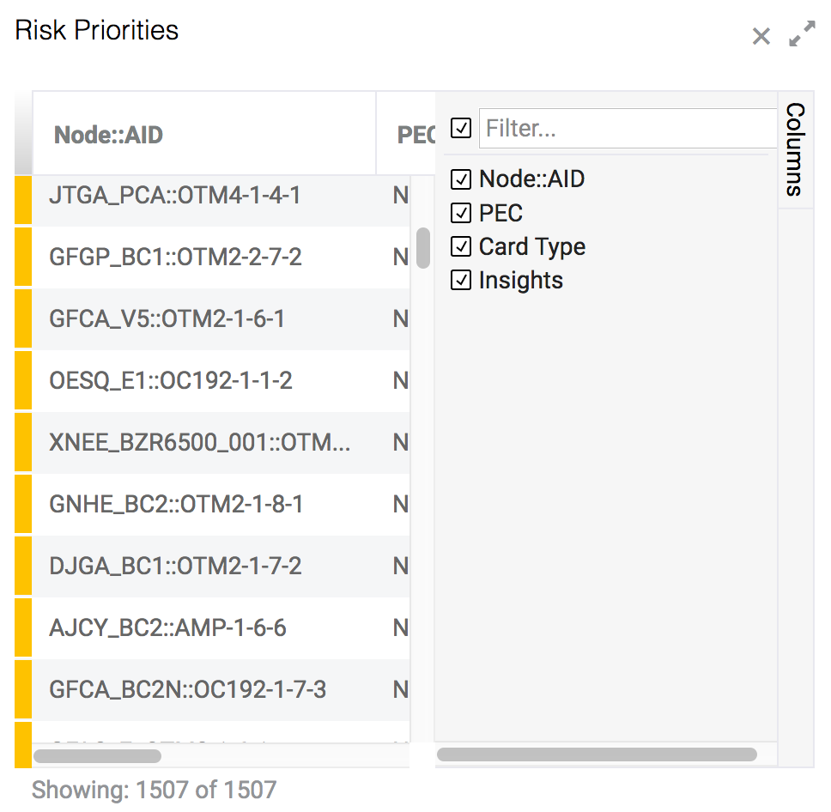

## Risk Details

This the engine of the dashboard, where you can see the average change detected, average slope, average time to threshold and average.

There is also an insights tab within the risk level that can be opened to create a form of engineer chat to prevent duplication of work when investigations are ongoing. To exit out of the insight you select the cross as indicated.

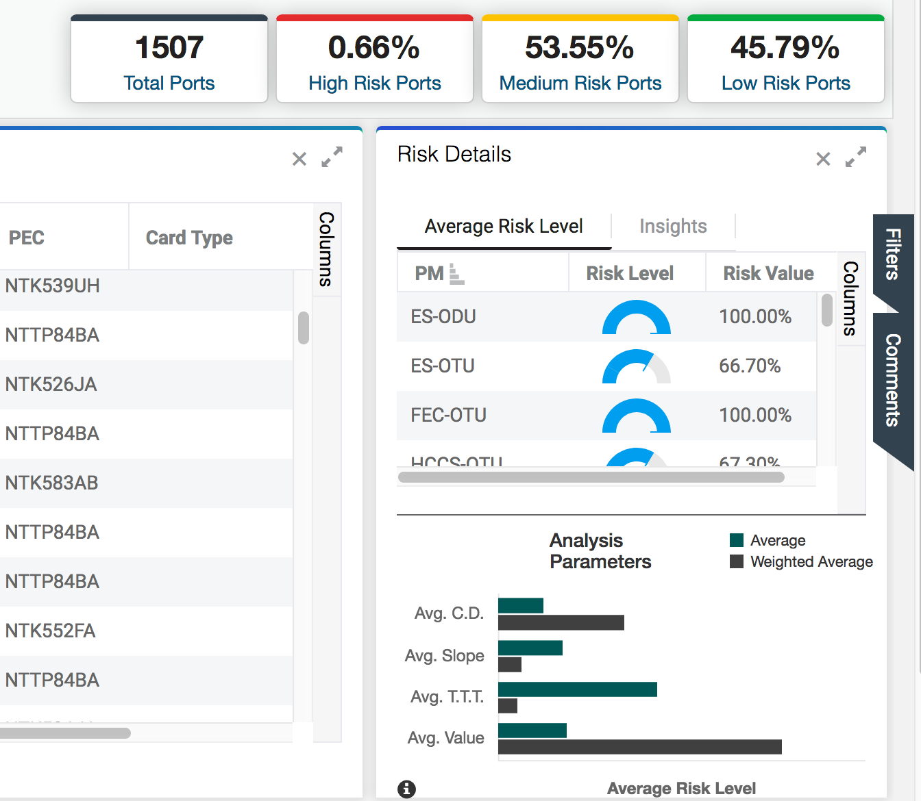

Insights tab:

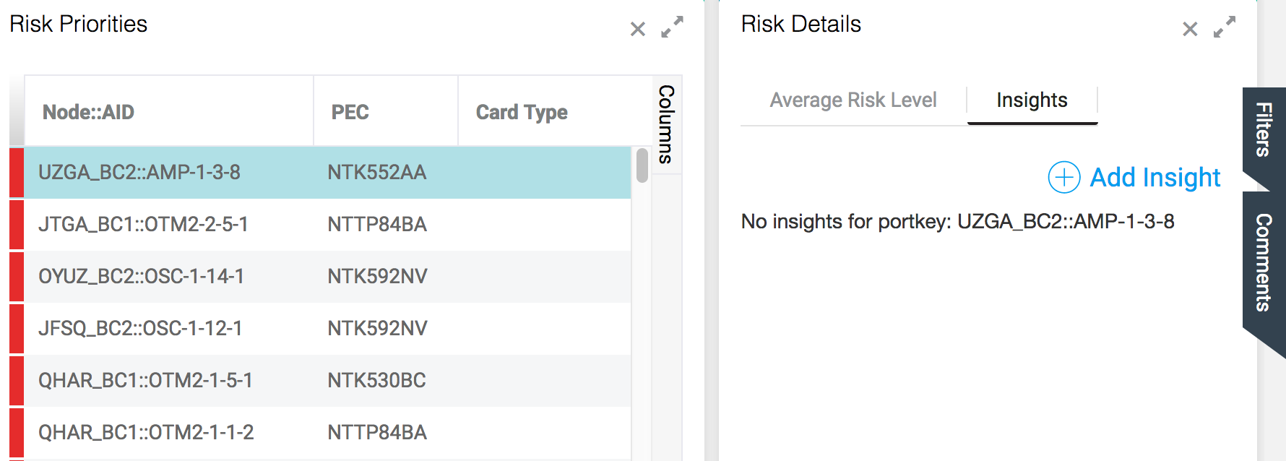

On the right hand side of the screen there are 2 tabs, and once user click on them the below side menu pops out. This gives user the ability to filter in various ways from network level down to card and port. User can filter on specific customers as well to look at only the network elements that interested. User can also filter on insights that are active\cleared and also risk level. To get rid of the side menu, simply click on the tab again. Comments is just another area for engineer to chat or collaborate.

Filters tab:

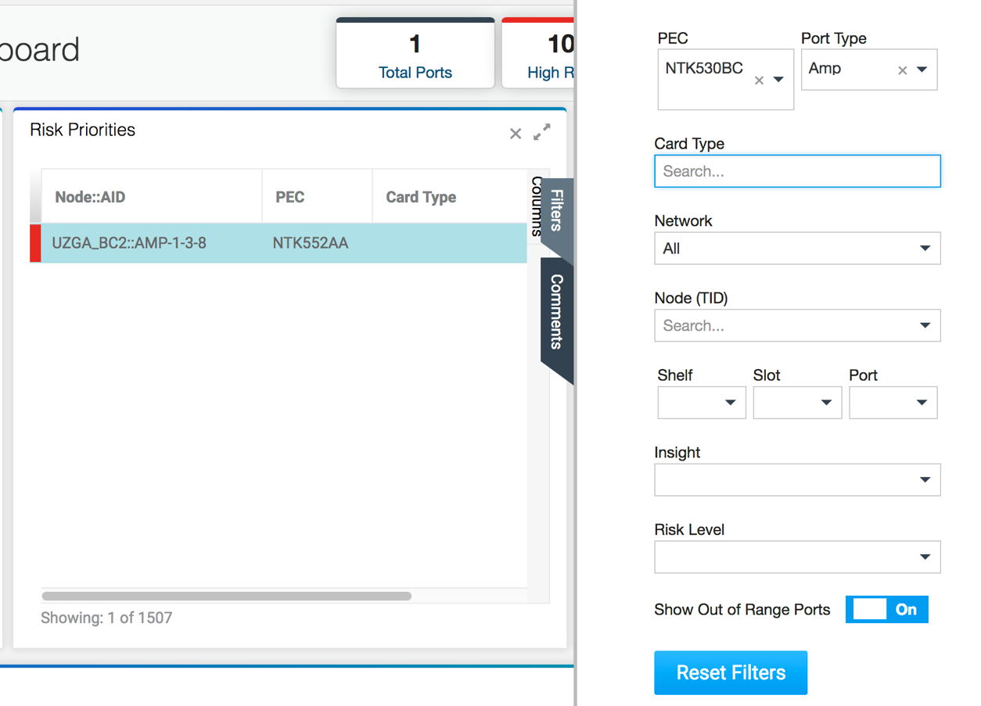

Comments tab:

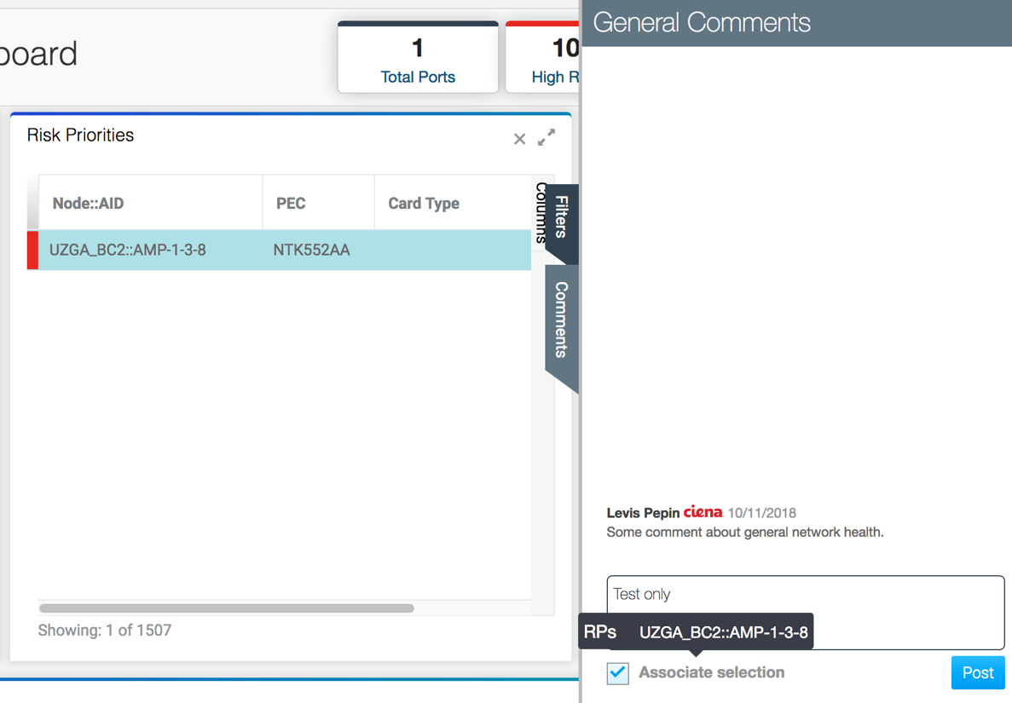

## PM Graph

This chart displays highest risk port. The chart will change depending on what node has been selected and therefore what port count is displayed and what card. To see the exact information contained in the port counts, hover the mouse over any dot on the chart, and the information.

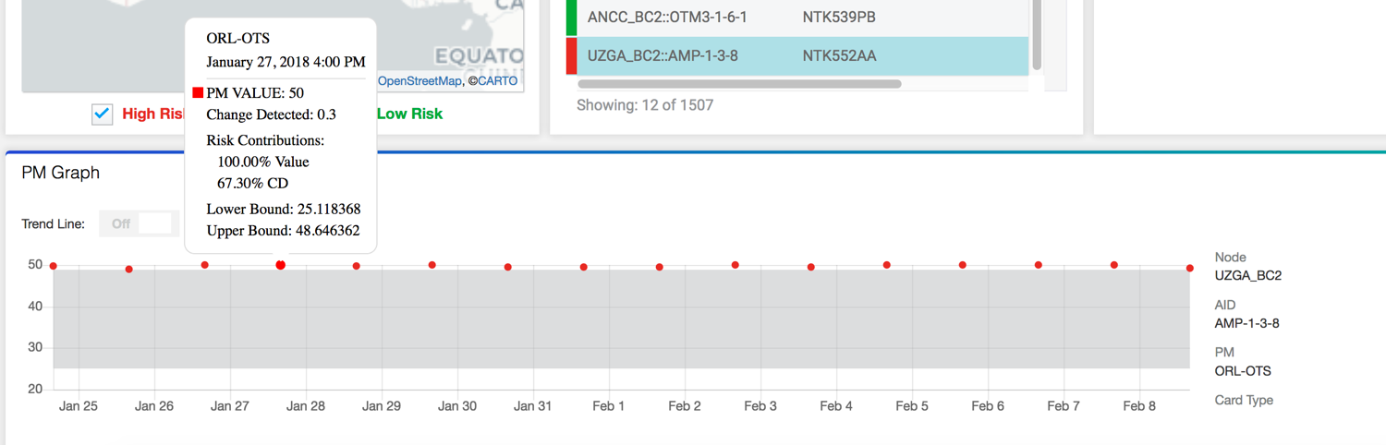

Turn off the boundary area to view the exact risk status of the port.

